**PF LAB   
Assignment No. 8  
Nested Loops**

**Name:** Ahmed Kasteer

**Roll Number:** 20F-0336

**Question 1:**

#include <iostream>

using namespace std;

int main()

{

int num;

cout << "Enter size of triangle" << endl;

cin >> num;

for(int i = 1; i <= num; i++)

{

for(int j = 1; j <= i; j++)

{

cout << "*";

}

cout << endl;

}

system ("pause");

}

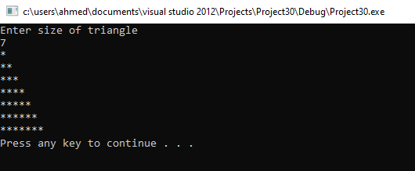

**Question 2:**

#include <iostream>

using namespace std;

int main()

{

int num;

cout << "Enter height of triangle"<< endl;

cin >> num;

for(int i = num; i >= 1; i--)

{

for(int j = 1; j <= i; j++)

{

cout << "*";

}

cout << endl;

}

system ("pause");

}

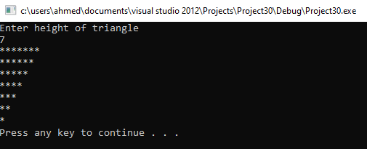

**Question 3:**

#include <iostream>

using namespace std;

int main()

{

int num;

cout<<"Enter triangle height "<<endl;

cin>>num;

for (int i = 1; i <= num; i++)

{

for (int space = num-i; space > 0; space--)

{

cout<<" ";

}

for(int j = 1; j <= i; j++)

{

cout<<"*";

}

cout<<endl;

}

system ("pause");

}

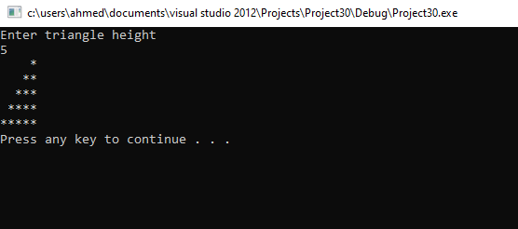

**Question 4:**

#include <iostream>

using namespace std;

int main()

{

int num;

cout<<"Enter triangle height "<<endl;

cin>>num;

for (int i = num; i >= 1; i--)

{

for (int space = num-i; space > 0; space--)

{

cout<<" ";

}

for(int j = i; j > 0; j--)

{

cout<<"*";

}

cout<<endl;

}

system ("pause");

}

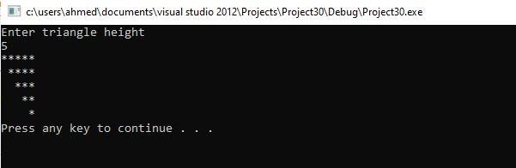

**Question 5:**

#include <iostream>

using namespace std;

int main()

{

int option;

cout << "Enter option 1, 2, 3 or 4 for triangle variations." << endl;

cin >> option;

switch (option)

{ {case 1:

int num;

cout << "Enter size of triangle" << endl;

cin >> num;

for(int i = 1; i <= num; i++)

{

for(int j = 1; j <= i; j++)

{

cout << "*";

}

cout << endl;

}

break;

}

case 2:

{int num;

cout << "Enter height of triangle"<< endl;

cin >> num;

for(int i = num; i >= 1; i--)

{

for(int j = 1; j <= i; j++)

{

cout << "*";

}

cout << endl;

}

break;

}

case 3:

{

int num;

cout<<"Enter triangle height "<<endl;

cin>>num;

for (int i = 1; i <= num; i++)

{

for (int space = num-i; space > 0; space--)

{

cout<<" ";

}

for(int j = 1; j <= i; j++)

{

cout<<"*";

}

cout<<endl;

}

break;

}

case 4:

{ int num;

cout<<"Enter triangle height "<<endl;

cin>>num;

for (int i = num; i >= 1; i--)

{

for (int space = num-i; space > 0; space--)

{

cout<<" ";

}

for(int j = i; j > 0; j--)

{

cout<<"*";

}

cout<<endl;

}

break;

}

default : cout << "Input valid choice." << endl;

}

system ("pause");

}

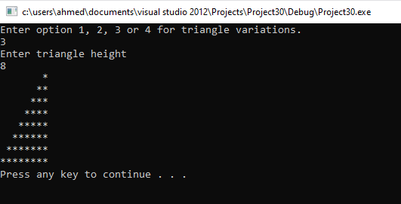

**Question 6:**

#include <iostream>

using namespace std;

int main()

{

int option;

cout << "Input option." << endl;

cin >> option;

switch(option)

{

case 1:

{

int n;

cout << "Enter height of square." << endl;

cin >> n;

for (int i = 1; i<= n; i++)

{

for(int j=1; j<= n; j++)

cout << "*";

cout << endl;

}

break;

}

case 2:

{

int n;

cout << "Enter height of square." << endl;

cin >> n;

for (int i = 1; i<= n; i++)

{

for(int j=1; j<= n; j++)

cout << i;

cout << endl;

}

break;

}

case 3:

{

int n;

cout << "Enter height of square." << endl;

cin >> n;

for (int i = n; i > 0; i--)

{

for(int j=1; j <= n; j++)

cout << i;

cout << endl;

}

break;

}

default : cout << "Enter correct choice. " << endl;

}

system ("pause");

}

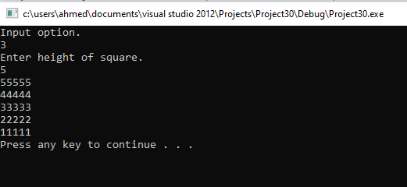

**Question 7:**

#include <iostream>

using namespace std;

int main()

{

int option;

cout << "Input option." << endl;

cin >> option;

switch(option)

{

case 1:

{

int num;

cout << "Enter height of triangle"<< endl;

cin >> num;

for(int i = num; i >= 1; i--)

{

for(int j = 1; j <= i; j++)

{

cout << "*";

}

cout << endl;

}

break;

}

case 2:

{

int num;

cout << "Enter height of triangle"<< endl;

cin >> num;

for(int i = 1; i <= num; i++)

{

for(int j = i; j <= num ; j++)

{

cout << i;

}

cout << endl;

}

break;

}

case 3:

{

int num;

cout << "Enter height of triangle"<< endl;

cin >> num;

for(int i = num; i >= 1; i--)

{

for(int j = 1; j <= i; j++)

{

cout << i;

}

cout << endl;

}

break;

}

default : cout << "Enter correct choice. " << endl;

}

system ("pause");

}

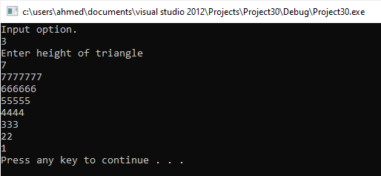

**Question 8:**

#include <iostream>

using namespace std;

int main()

{

int option;

cout << "Input option." << endl;

cin >> option;

switch(option)

{

case 1:

{

int n;

cout << "Enter height of square." << endl;

cin >> n;

for (int i = 1; i<= n; i++)

{

for(int j=1; j<= n; j++)

cout << i;

cout << endl;

}

break;

}

case 2:

{

int n;

cout << "Enter height of square." << endl;

cin >> n;

for (int i = 1; i<= n; i++)

{

for(int j=1; j<= n; j++)

cout << j;

cout << endl;

}

break;

}

case 3:

{

int n;

cout << "Enter height of square." << endl;

cin >> n;

for (int i = n; i > 0; i--)

{

for(int j=1; j <= n; j++)

cout << i;

cout << endl;

}

break;

}

case 4:

{

int n;

cout << "Enter height of square." << endl;

cin >> n;

for (int i = n; i > 0; i--)

{

for(int j=n; j >= 1; j--)

cout << j;

cout << endl;

}

break;

}

default : cout << "Enter correct choice. " << endl;

}

system ("pause");

}

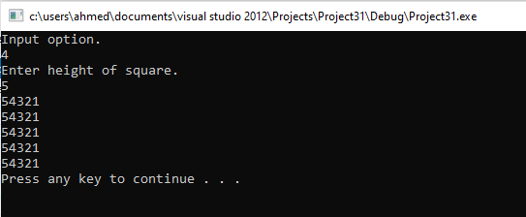

**Question 9:**

#include <iostream>

using namespace std;

#include <iomanip>

int main()

{

int i,j,k,c=5;

for(i=1 ; i<=5; i++)

{

for(k=1;k<=c;k++)

cout << " ";

for(j=1;j<=i;j++)

cout<<setw(2)<<"*";

cout << endl;

c--;

}

system ("pause");

}

